    - Training Algorithm

    - Admin Monitoring Algorithm

Fig. 1: Overview Architecture Diagram of the Proposed System
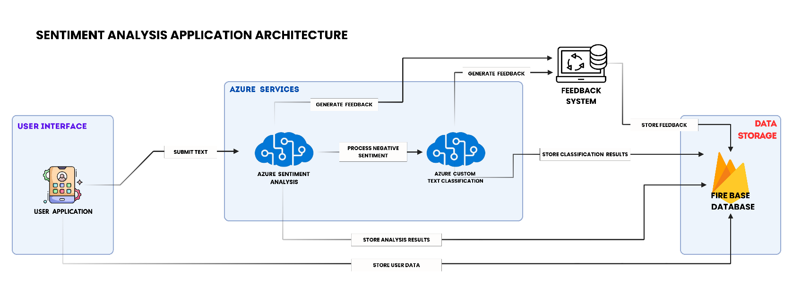

Fig. 2 Sentiment Analysis and Mental Health Assessment using Azure Tools
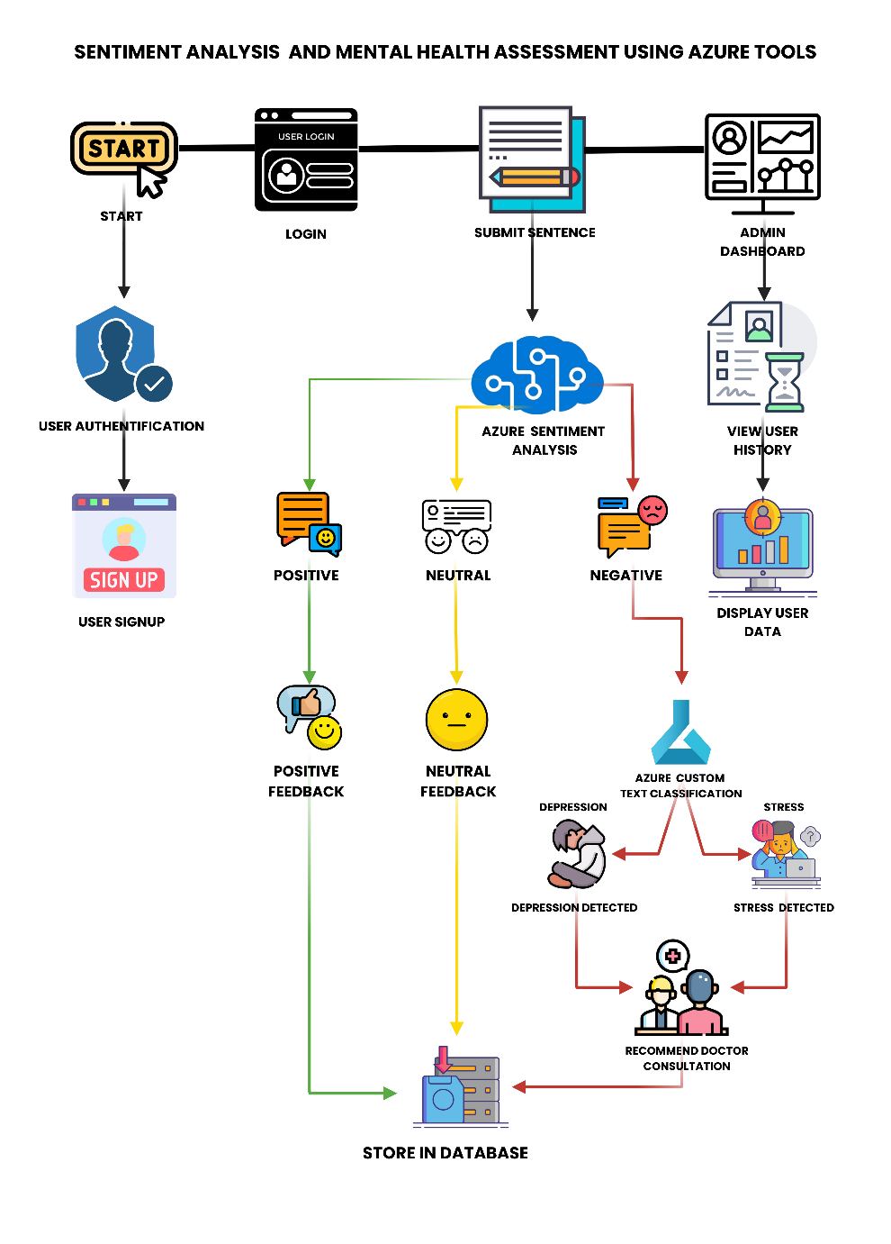

EQUATIONS IMAGES:

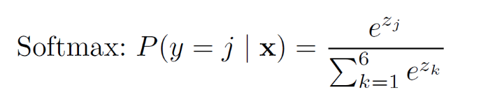

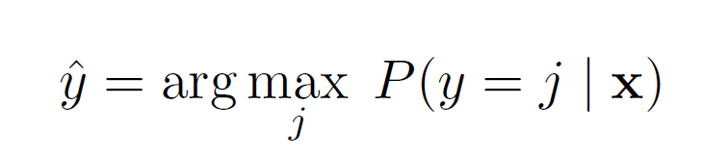

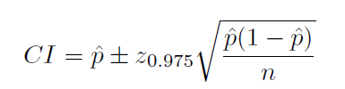

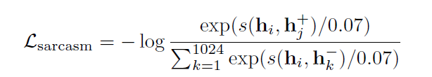

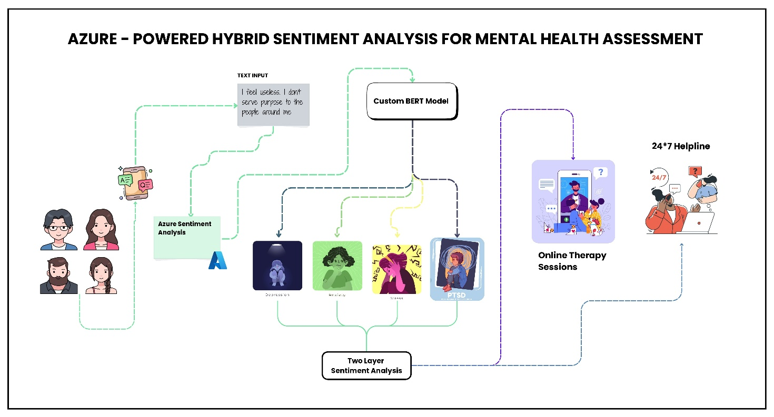
Graphical Abstract

Azure-Powered Hybrid Sentiment Analysis for Mental Health Assessment: A Two-Layer Framework Integrating Clinical Text Classification and Sarcasm Processing
Description of the Graphical Abstract:
The graphical abstract illustrates the end-to-end architecture of our proposed system for mental health state detection and monitoring. It features a two-stage processing pipeline designed for real-time analysis and feedback:
- Stage 1: Sentiment Analysis — User-generated text is analyzed using Microsoft Azure’s cloud-based sentiment analysis API to classify emotional tone as positive, neutral, or negative.
- Stage 2: Mental Health Classification — If the sentiment is negative, the input is passed to an Azure custom text classification network trained to detect mental health conditions such as depression, anxiety, stress, and many more.
- Feedback and Monitoring — The system generates real-time, personalized user feedback and enables clinicians to monitor trends and patterns via a secure dashboard.
- Data Storage and Privacy — All data is handled in compliance with stringent privacy regulations, ensuring secure storage and ethical use of sensitive information.
This visual representation encapsulates the novelty of our approach: a robust, intelligent, and scalable mobile platform that integrates cloud sentiment tools with advanced deep learning to facilitate accessible and accurate digital mental health assessments.

